How the Web Works

* DEFINITIONS AND HISTORY

The **World-Wide web** (WWW or simply web) is the subset of internet.

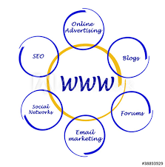

The invention of the **WWW** is usually attributed to the British Tim Berners-Lee, who, along with the belgian Robert Cailliau, published a proposal in 1990 for a hypertext system while both were working at CERN in Switzerland.

* Features of Web

1.WWW supports TCP/IP services, such as ***Gopher, FTP*** in addition to HTTP.

2.WWW is a ***search tools***. It helps you find and retrieve information.

3.WWW can handle different text formats and different methods of organizing information.

4.you can keep in touch with friends and relatives.

* Web Server Basics

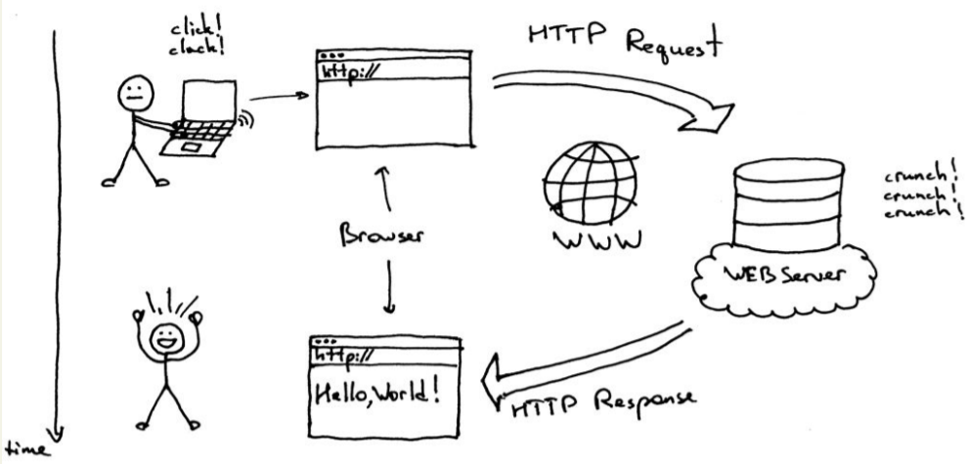

* Static Web page

A **static web page** is a web page that is delivered to the user's web browser exactly as stored, in contrast to dynamic web pages which are generated by a web application.

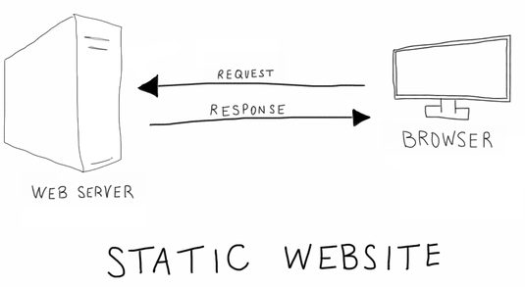

* Dynamic Web page

A server-side **dynamic web page** is a web page whose construction is controlled by an application server processing server-side scripts. In server-side scripting, parameters determine how the assembly of every new web page proceeds, including the setting up of more client-side processing.

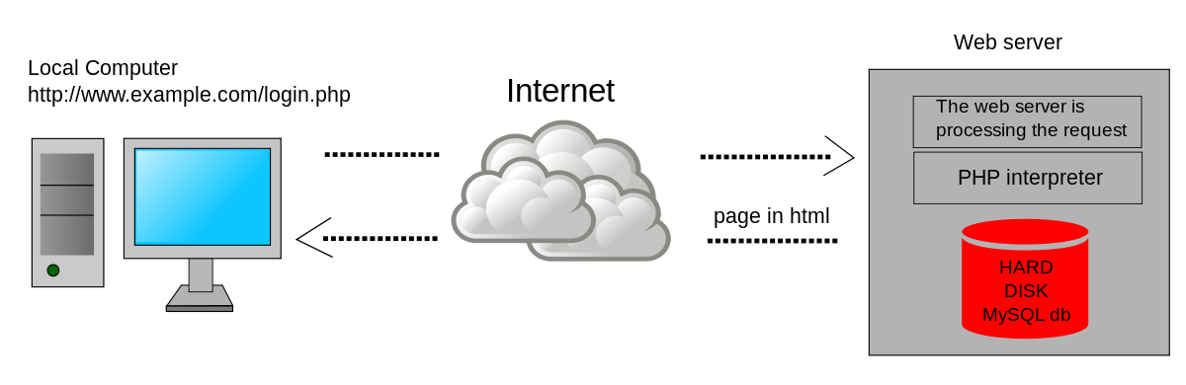

* Client-Server Model

The **client**-**server model** describes how a **server** provides resources and services to one or more **clients**. Examples of servers include web servers, mail servers, and file servers. Each of these servers provide resources to **client** devices, such as desktop computers, laptops, tablets, and smartphones.

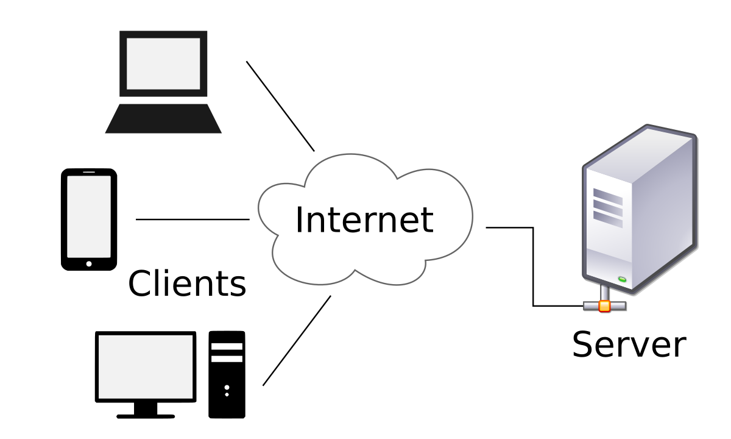

* Domain Name System

The **domain name system** (**DNS**) is a **naming** database in which internet **domain names** are located and translated into internet protocol (IP) addresses. The **domain name system** maps the **name** people use to locate a website to the IP address that a computer uses to locate a website.

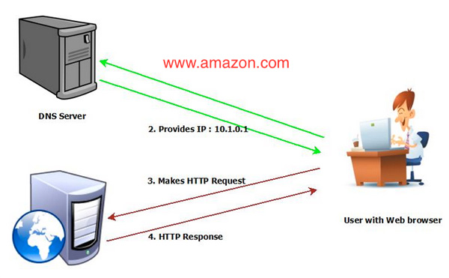

* Uniform Resource Locators (URL)

A **URL (Uniform Resource Locator)** is a unique identifier used to locate a resource on the internet. It is also referred to as a web address. URLs consist of multiple parts -- including a protocol and domain name -- that tell a web browser how and where to retrieve a resource.

End users use URLs by typing them directly into the address bar of a browser or by clicking a hyperlink found on a webpage, bookmark list, in an email or from another application.

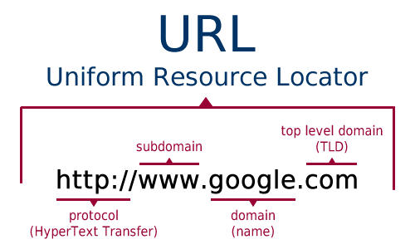

* Hypertext Transfer Protocol (HTTP)

The **Hypertext Transfer Protocol** (**HTTP**) is an application layer protocol for distributed, collaborative, hypermedia information systems. HTTP is the foundation of data communication for the World Wide Web, where hypertext documents include hyperlinks to other resources that the user can easily access, for example by a mouse click or by tapping the screen in a web browser.

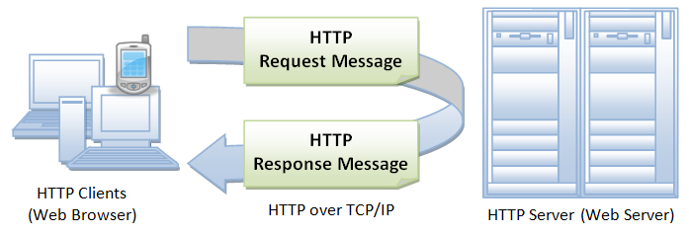

* Web Servers

A **web server** is server software, or hardware dedicated to running this software, that can satisfy client requests on the World Wide Web. A web server can, in general, contain one or more websites. A web server processes incoming network requests over HTTP and several other related protocols.

